Surgical anatomy of breast
[TIP] Are the terms ‘breast’ and ‘mammary gland’ same?
No.
'Mammary gland' indicates simply the gland part.
'Breast' indicates associated skin, fat and connective tissue.

Mammary gland
Location
Breast is located in superficial fascia of pectoral region.
Usually from 2nd to 6th rib
Its tail – axillary tail of Spence extends towards axilla underneath the deep fascia.
This is the only part of normal breast present beneath the deep fascia.
[NOTE]Knowledge of location of breast is important in assessing extent of tumor in relation to pectoral fascia.
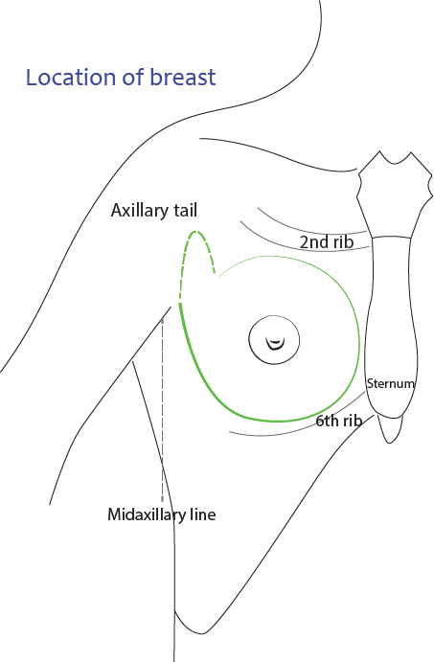
[YOUTUBE] https://www.youtube.com/watch?v=GFbY-0TWpFw

Deep fascia and mammary gland
Deep fascia in the region of breast is the fascia covering the pectoral muscle.
It forms the interface between muscle and gland.
As it is related to pectoral muscle, it is called pectoral fascia.
[TIP]A potential space, between superficial fascia enclosing breast tissue and deep fascia is retromammary space.
Breast moves freely as it is present in the superficial fascia and nothing is attached to its deeper surface.
It moves in the plane of retromammary space and submammary space.
[CLINICAL]Collection of pus in retromammary space is referred as retromammary abscess.
[WARNING]Infiltration of carcinoma from breast into deep fascia attaches it to deep fascia. Its mobility becomes restricted. The condition referred as ‘fixity’ of breast.

Suspensory ligament
Suspensory ligaments of Cooper are special connective tissue bands, anchoring the breast parenchyma.
They extend from skin to deep layer of superficial fascia.
[CLINICAL]Infiltration of carcinoma along suspensory ligaments results in puckering or dimpling of skin.

Mammary bed
Three muscles form the base of breast.
- Major part of breast is in contact with pectoralis major.
- Serratus anterior is related superolateral aspect.
- Aponeurosis of external oblique is related to inferior aspect.
[CLINICAL]While testing the spread of cancer to its base from the mammary gland, the knowledge of extent and action of these muscles is of prime importance.
[WARNING]While operating breast tumor, the nerves supplying serratus has to be spared, otherwise it results in loss of action.

Nipple
Nipple is covered by thin hairless skin, having numerous sweat and sebaceous glands which open directly onto the skin surface.
The skin of the nipple and areola is rich in melanocytes and is therefore typically darker than the skin covering the remainder of the breast.
The oily secretion of these specialized sebaceous glands acts as a protective lubricant and facilitates sucking action during lactation.

Montegomery tubercles
Specialized sebaceous glands enlarge during pregnancy and form subcutaneous tubercles called Montegomery tubercles.
Oily secretions of these glands lubricate nipple during sucking.
[CLINICAL]The glands are present even before pregnancy but become pronounced during pregnancy and lactation.
They are named after an Irish obstetrician Dr William Fetherstone Montgomery who first described them in 1837.

Structure of breast
- Each breast composed of 15 to 20 lobes, within the superficial fascia.
- These lobes along with their ducts form anatomic units, but not surgical units.
- Lobes and their parenchyma are arranged radially with respect to position of nipple.
- So that ducts radiate concentrically to nipple and terminate ‘separately’ into the summit of nipple.
- The part of duct within the nipple is the narrowest portion of the duct.
- Secretions or sloughed cells tend to collect within this narrow part of the duct.
- This results in expansion of ducts which are called lacticiferous sinuses.
- All the above mentioned structures constitute epithelial component of breast.
The ducts are surrounded by connective tissue derived from upper superficial papillary layer of dermis. Between the ducts a less cellular connective tissue derived from reticular layer of dermis is present. This forms the connective tissue component of breast.
[CLINICAL]Tumors are the most important lesions of the female breast. They may arise from either connective tissue or epithelial structures.
[TIP]Neoplasms of epithelial origin are more common.
[WARNING]Cancers arising from lobules are called lobular carcinoma and those from ducts are ductal carcinoma.
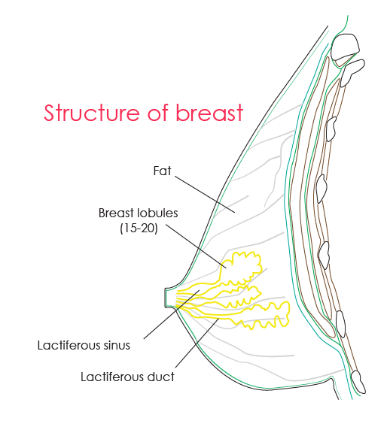
[YOUTUBE] https://youtu.be/k2Fsci1g_Wk
Arterial supply of breast and surgical importance
Breast is receives blood from three important sources: internal thoracic artery, braches of axillary artery and intercostal arteries.
- Branches from lateral thoracic artery
- 2nd, 3rd and 4th Perforating branches from Internal thoracic artery
- Pectoral braches of acromiothoracic and superior thoracic artery
- 2nd, 3rd and 4th posterior intercostal arteries
[CLINICAL]Surgical importance:
Braches of internal thoracic artery descend to the medial side of breast above the nipple. So a ‘radial’ incision is less likely to injure the these vessels than a transverse incision in upper half of the breast.
Inferior part of breast, below nipple is almost free of blood vessels.
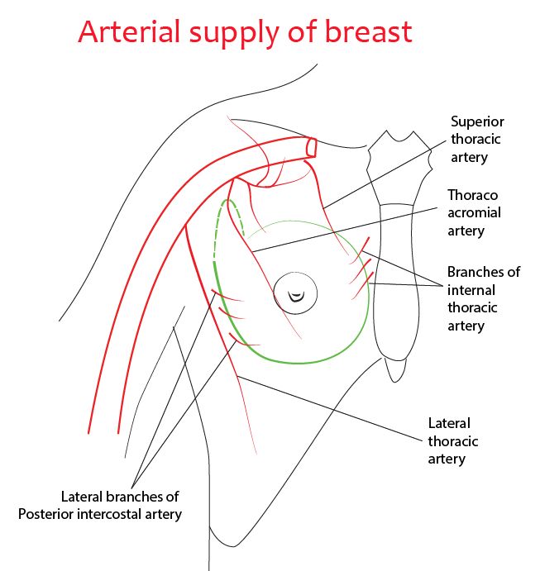

Venous drainage of breast and spread of tumor
Most veins from breast follow arteries. The axillary, internal thoracic, and the third to fifth intercostal veins drain the mammary gland.
- The perforating tributaries from the medial half of the breast carry the greater part of the venous drainage. They enter the internal thoracic vein and then to brachiocephalic vein.
- The axillary vein receives one or two pectoral branches from the breast.
- The intercostal veins communicate posteriorly with the vertebral venous system, which enters the azygos, hemiazygos, and accessory hemiazygos veins, which in turn drain to the superior vena cava. Anteriorly, they communicate with the brachiocephalic vein by way of the internal thoracic veins
[CLINICAL]Spread of tumor:
By the first two pathways, metastases of the breast readily reach the lungs. By the third pathway, metastases may travel to the skeleton and the central nervous system.
Through one or more of portocaval anastomoses, metastatic cells from the breast may reach the liver.
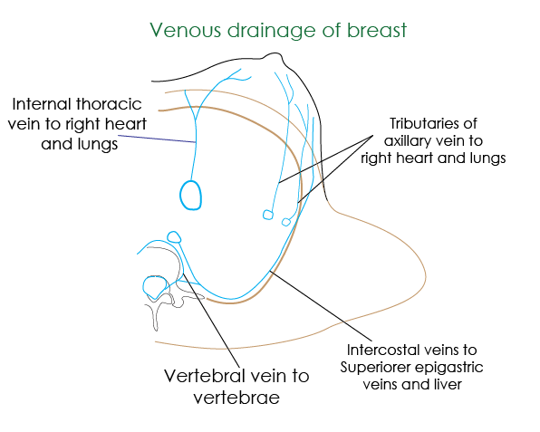
[TIP]Watch the video
[YOUTUBE] https://www.youtube.com/watch?v=yERBNAGLbfA

Breast quadrants
Breast is divided into four quadrants
- Upper inner
- Upper outer
- Lower inner
- Lower outer
[CLINICAL]Breast tumors are most common in upper outer quadrant.

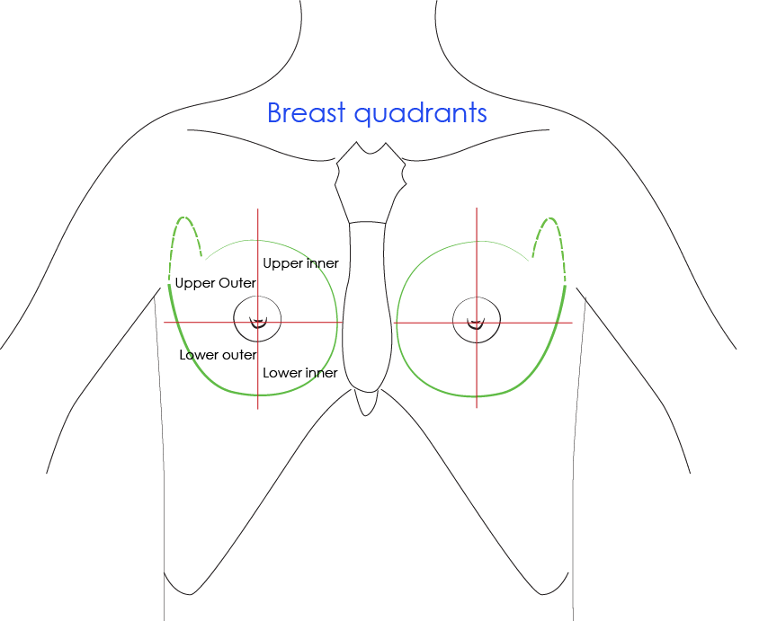

Development
• Breast develops from epidermis
Breast may develop in any region along the milk line
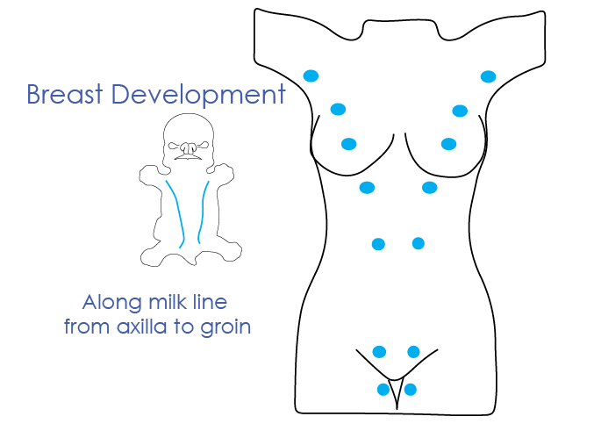

Applied aspects - breast cancer
- Tumors are the most important lesions of the female breast.
- They may arise from either connective tissue or epithelial structures.
- Neoplasms of epithelial origin are more common.
- Cancers arising from lobules are called lobular carcinoma and those from ducts are ductal carcinoma.

Tell-tale signs of malignancy
Breast lesions with these features are more likely to be cancerous
- Hard
- Irregular
- Tethered
- Fixed
- Painless lesions

Applied aspects – mastectomy
Mastectomy is removal of breast
- Radical Halsted mastectomy - excision of the breast, axillary lymph nodes and pectoralis major and minor muscles
- Modified radical (Patey) mastectomy – excision of whole breast, large portion of skin, the centre of which overlies the tumour with nipple (always), fat, fascia and lymph nodes of the axilla
- Simple mastectomy involves removal of only the breast with no dissection of the axilla except for axillary tail of Spence.

Possible complications of mastectomy
- Vascular Injury leading to haemorrhage – from the perforating arteries and veins, especially those of the first and second intercostal vessels, the axillary vein and its tributaries, the axillary artery and its branches.
- Nerve Injury:
  - Thoracodorsal Nerve: internal rotation and abduction of shoulder are weakened
  - Long Thoracic Nerve: results in the "winged scapula" deformity
- Lymphatic obstruction:
  - Results in Peau d’orange - caused by cutaneous lymphatic oedema
  - Infiltrated skin is tethered by the sweat ducts it cannot swell, leading to an appearance like orange skin

Modes of breast reconstruction
- Silicone gel implant under the pectoralis major muscle
- A musculocutaneous flap can be constructed either from the
  - latissimus dorsi muscle (an LD flap)
  - transversus abdominis muscle (a TRAM flap)

Retraction or dimpling of the skin
Malignant invasion of the ligaments of Cooper
Shortens these connective tissue fibres - produces dimpling of the skin

Peau d'orange
Irregular, roughened appearance of the skin
Obstruction of the subcutaneous lymphatics - results in peau d'orange appearance
___MCQ_START___

Q1. Which statement best distinguishes the terms breast and mammary gland?
A. Breast refers only to glandular tissue
B. Mammary gland includes skin and fat
C. Mammary gland refers only to glandular tissue, while breast includes skin, fat, and connective tissue [CORRECT]
D. Both terms are anatomically identical
___
Q2. The axillary tail of Spence is unique because it:
A. Lies entirely within the deep fascia
B. Is the only part of the normal breast present beneath the deep fascia [CORRECT]
C. Contains no glandular tissue
D. Drains exclusively to internal mammary lymph nodes
___
Q3. The potential space that allows free mobility of the breast over the pectoral fascia is the:
A. Subcutaneous space
B. Interpectoral space
C. Retromammary space [CORRECT]
D. Axillary space
___
Q4. Puckering or dimpling of the skin in carcinoma of the breast is caused by infiltration of:
A. Lactiferous ducts
B. Retromammary space
C. Suspensory ligaments of Cooper [CORRECT]
D. Pectoral fascia
___
Q5. Breast tumors are most commonly located in which quadrant of the breast?
A. Upper inner quadrant
B. Lower inner quadrant
C. Upper outer quadrant [CORRECT]
D. Lower outer quadrant
___
___MCQ_END___

